TECHNICAL PROJECT REPORT

# Title of Invention / Project:

SMART DUSTBIN.

Team Members / Inventors:

|  |  |  |  |  |  |
| --- | --- | --- | --- | --- | --- |
| **S. No.** | **Name** | **Department** | **Designation** | **Mobile** | **E-Mail** |
| 1. | Lokesh deshwal | CSE(AI&ML) | Student | 9813419698 | Laveshdeshwal30@gmail.com |
| 2. | Anshul yadav | CSE(AI&ML) | Student | 9057811292 | anshulyadavpoata@gmail.com |
| 3. | Kamal sharma | CSE(AI&ML) | Student | 8556914582 | Kamal01051998@gmail.com |
| 4. | Khushal Thakur | ECE | Mentor | 9646030764 | khushal.thakur@cumail.in |
| 5. | Anshul Sharma | ECE | Mentor | 9478697475 | anshulsharma.ece@cumail.in |
| 6. | Kiran Jot Singh | ECE | Mentor | 9463909689 | kiranjotsingh.ece@cumal.in |
| 7. | Divneet Singh Kapoor | ECE | Mentor | 9878422653 | divneet.ece@cumail.in |

***Section – 1 (IPR Related)***

# Abstract:

In this 21 century in countries with the billions of the people ,everyday tons of waste is being generated .Garbage management has become the one of the most biggest task for the municipal authorities.But it is found in most of the places majority of time that the dustbin would be open .also one can observe that the dustbin is overflowing and neither the citizen nor the authorities would dispose the waste or empty the bin at the right time .This project is the providing the solution of this problem .basically smart dustbin is the phase of the garbage management .the automatic open and close feature has been provided so that the dustbin remains open only when the waste is thrown and when nobody is using it nor would the animal come and pick something from it the dustbin is also interfaced with the sensor that sends the signals to the arduino nano to give command to the servo motor to open the lid of the dustbin and the dustbin will come . by using this type of project the flyes could not be able to move above the garbage and help us from being unhealthy .it can also help a old person to open the dustbin without any efforts .

In this project we have made a dustbin that will automatically open and close when move our hand across the dustbin front where there is an ultrasonic sensor is being fitted so the as we move our hand across it the it will send command to the arduino nano to give command to the servo motor to open the lid and allow the waste material to throw off.

The additional modification that can be made in this project is to implement a project of the IOT BASED SMART GARBAGE.BASICALLY it will be the shoot sonar waves to know how much stuff is inside the container .we will also measure the temperature inside the container .data collected from the sensor are sent over the cellular network (GPRS) for the analysis of the displayed on Ubidots web platform for the customer .a list of containers is to be collected can the be sent to the drivers to plan an efficient route . the will also include the real time monitoring of the civic body garbage vehicles using RFID. The vehicles owner has to flash this RFID card so that who and when and what time garbage bin were emptied .it will help to curb laziness of the municipals garbage collectors

Existing state-of-the-art and Drawbacks in existing state-of-the-art

|  |  |  |
| --- | --- | --- |
| **S. No.** | **Existing state of art** | **Drawbacks in existing state of art** |
| 1 | In this project i have solved the problem of the being the opening and the closing of the lid of the dustbin .In this project it  will open as we move our hand across the sensor then the lid will open after that with the couple of 3 second it will close automatically .This will also help in the time management. | The drawbacks of the existing states are that the  sensors are not working well and and it takes a lot of time to being open the lid of the dustbin due to that we all have to suffer from the time management system . |
| 2 | In this we have removed the complexation of the circuit and made the circuit very simple so that the people who sees it will be able to understand without any difficulty .And help them to make any change in the project or the further modification in the project and help them for the further reference . | The drawback in this existing state  is that the circuit is very complex so that we cannot be able to  differentiate the wires of the circuit due to which we need to have suffer from the circuit complexion.which confuses the people |

# Novel/Additional modifications that you can propose to improve upon drawbacks

I will make a change such that the project will consume a less amount of the power from the battery and will give us a lot of time for the battery usage of the battery power.It should be power efficient I will such  type of change in the project that if the dustbin is filled with the garbage then it will send me a message that the dustbin is filled and we will get to know that we have to empty the dustbin.

Advantages **:** It will stop overflowing of dustbins along roadsides and localities as smart bins are managed at real time. The filling and cleaning time of smart bin will also be reduced thus making empty and clean dustbins available to common people.

# Block Diagram

Controller

**DUSTBIN CONTROL**

**SERVO**

**MOTOR**

**ULTRASONIC SENSOR**

SECTION-2 (REAL PROJECT)

|  |  |  |  |
| --- | --- | --- | --- |
| S.No | Product name | Quantity | Price |
| 1. | Arduino nano | 1 | 315 |
| 2. | Servo motor | 1 | 150 |
| 3. | Ultrasonic sensor | 1 | 175 |
| 4. | switch | 1 | 10 |
| 5. | Battery 9V | 1 | 25 |
| 6. | Paper board | 1 | 20 |
| 7. | Jumper wire | 10  TOTAL=725. | 30 |

CIRCUIT DIAGRAM:

Steps of circuit completion.

1.first take an arduino nano and do soldering as per the need of the circuit .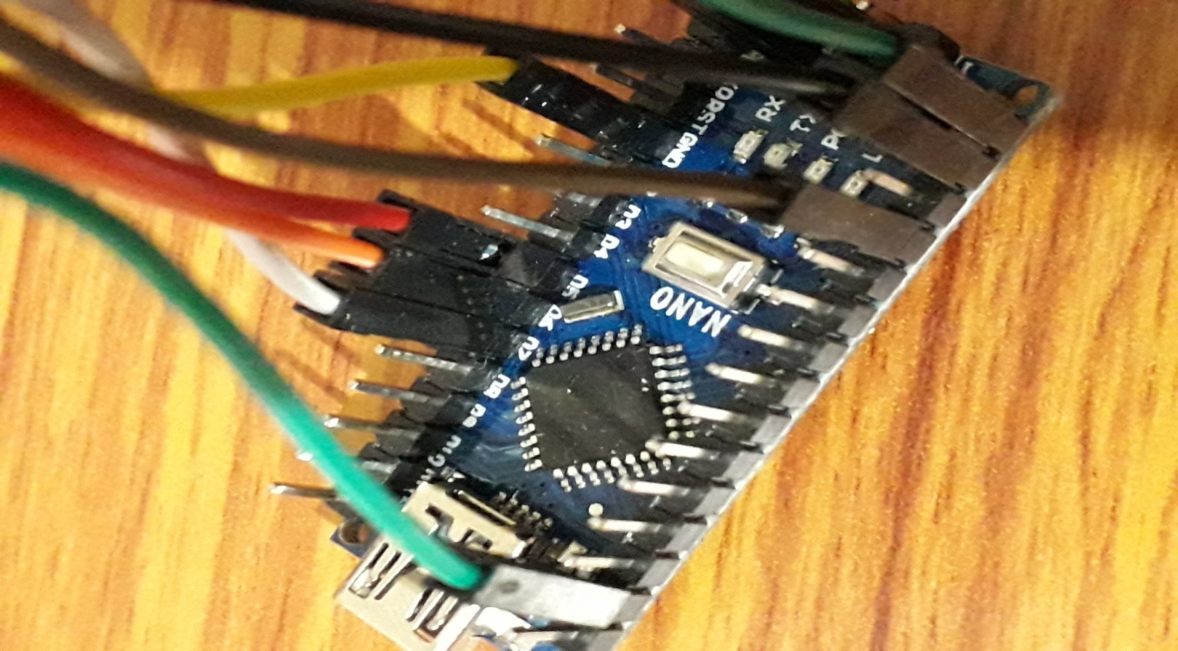2.After that buy up a ultra sonic sensor which is used to sense the the object near or far of it it based on the releasing the ultra sonic wave .

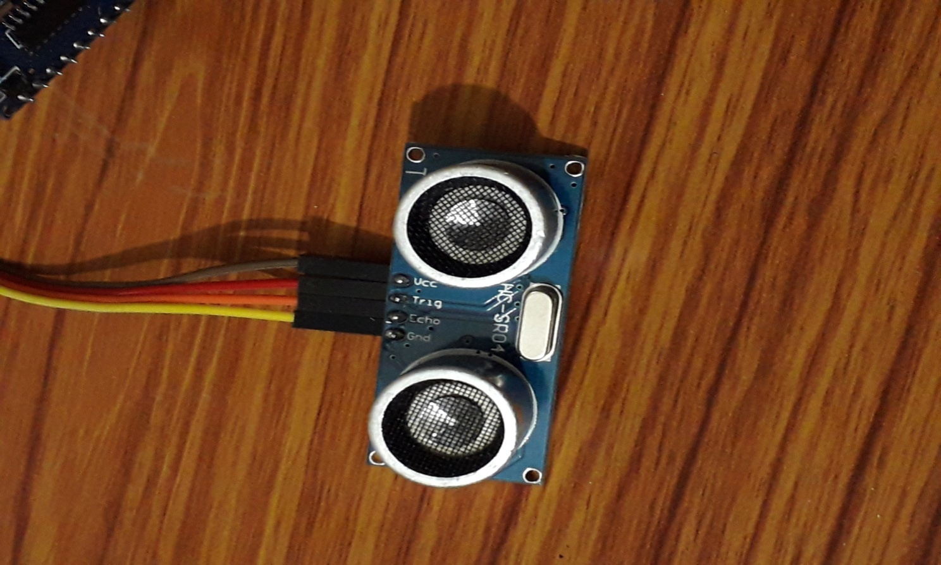

3.After that take a servo motor of 9G that is used to open and close the lid of the dustbin .

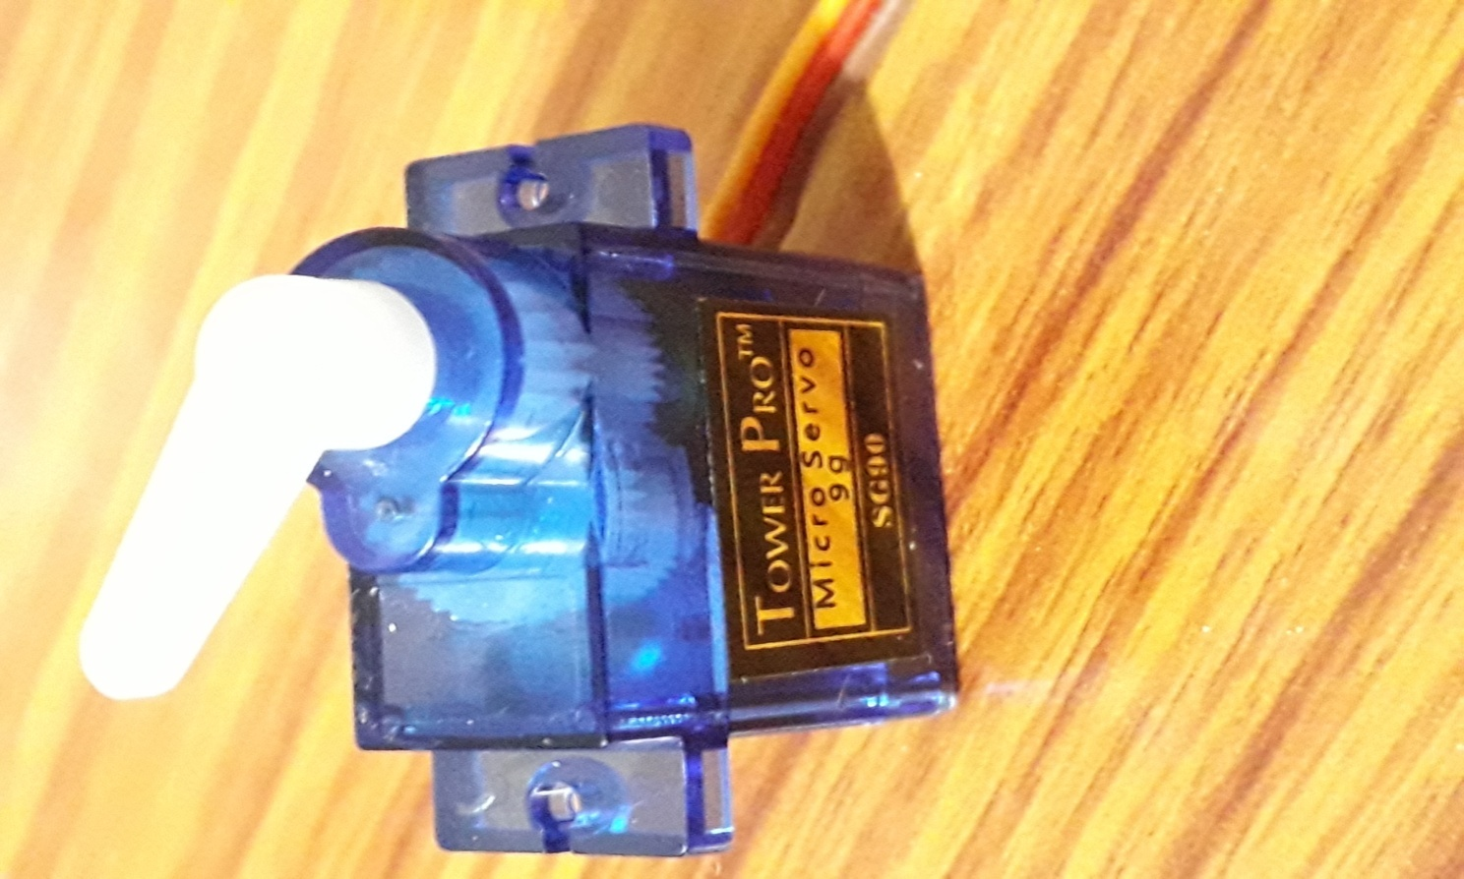4.we need a 9V battery that is being used to provide the external supply to the project .With which help we can be able to run the project after being uploading the code into the arduino nano.

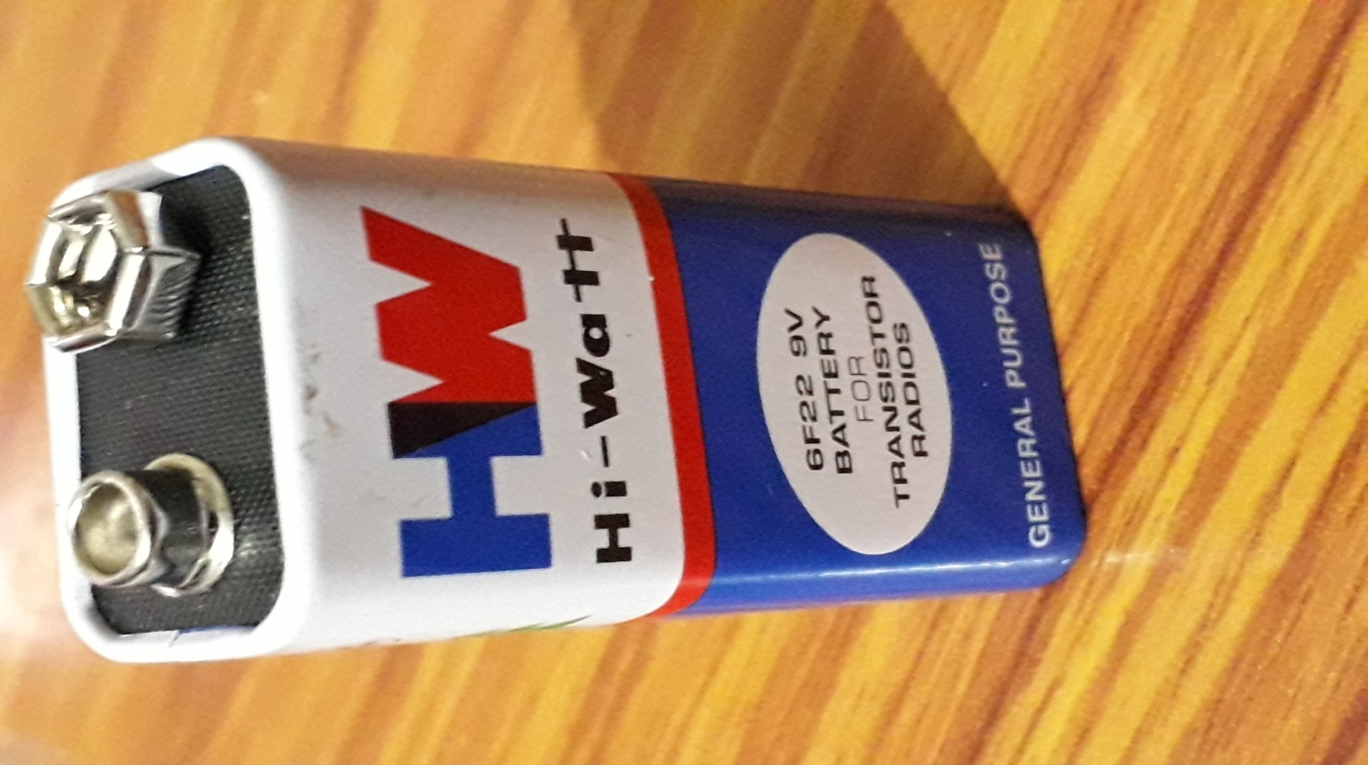5.After all of the those we need to have connection all of then according to the code that we have made to being uploading in the arduino .The connections of the ultrasonic sensors are being as that the

A:.echo pin of the sensor is connected to the the pin 6 of arduino

B:.Trig pin is connected to pin 5

C:.Vcc is connected to the 5V

And the servo motar pins are being connected as main wire is connected to the 3V3 and one is connected to the ground and another is connected to the pin 7.

Now the connection is that the main wire is connected to the VIN of the arduino and neutral wire is connected to the ground .

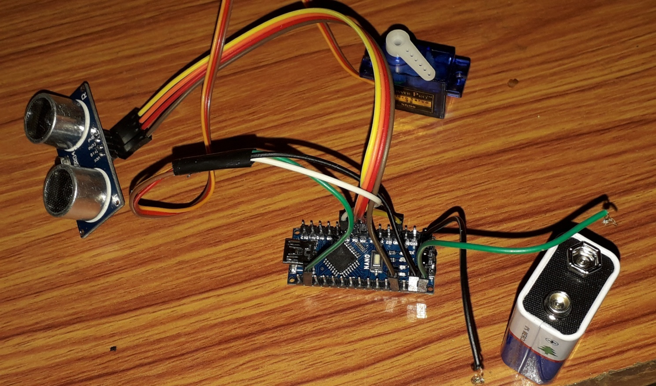6.After that the final look of the project is as being as that being shown in the photo and the working of the project is being shown in the next how the lid open as we move our hand across the sensor and the lid will automatically open after the 3S it will close automatically

It is all about the project of the smart dustbin as everything is being described with brief and with the photos to make you understood more clearly that will help you to make more beneficial another project :

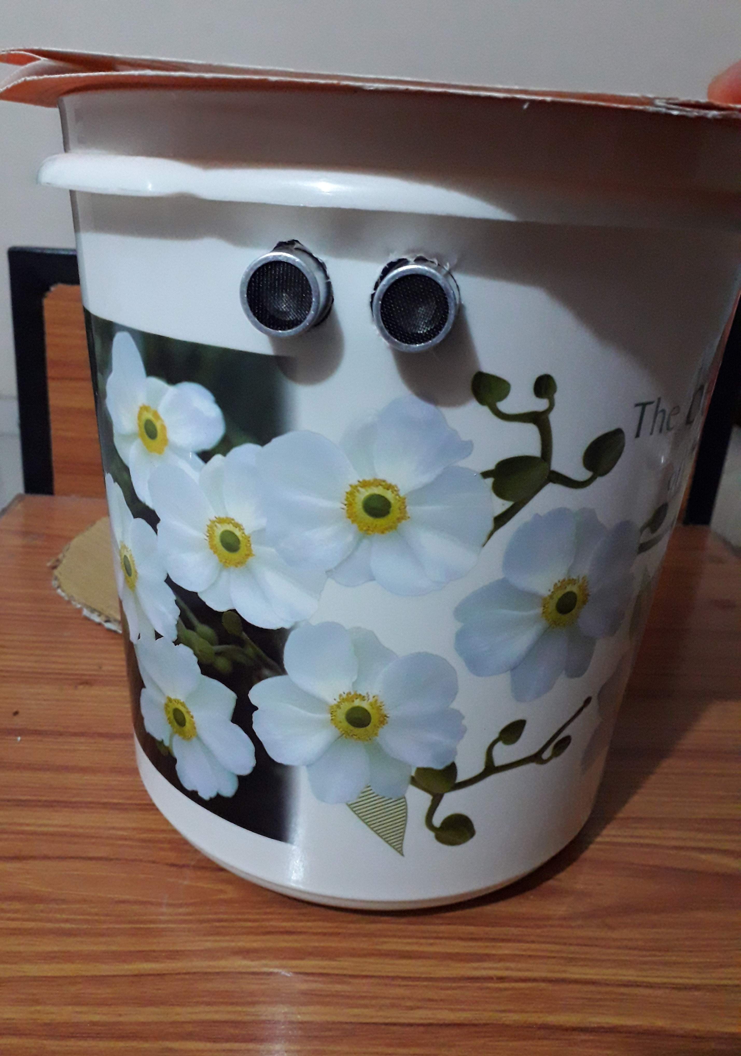**The real picture of the project how the dustbin look like.**

**This picture show that when the lid opens**

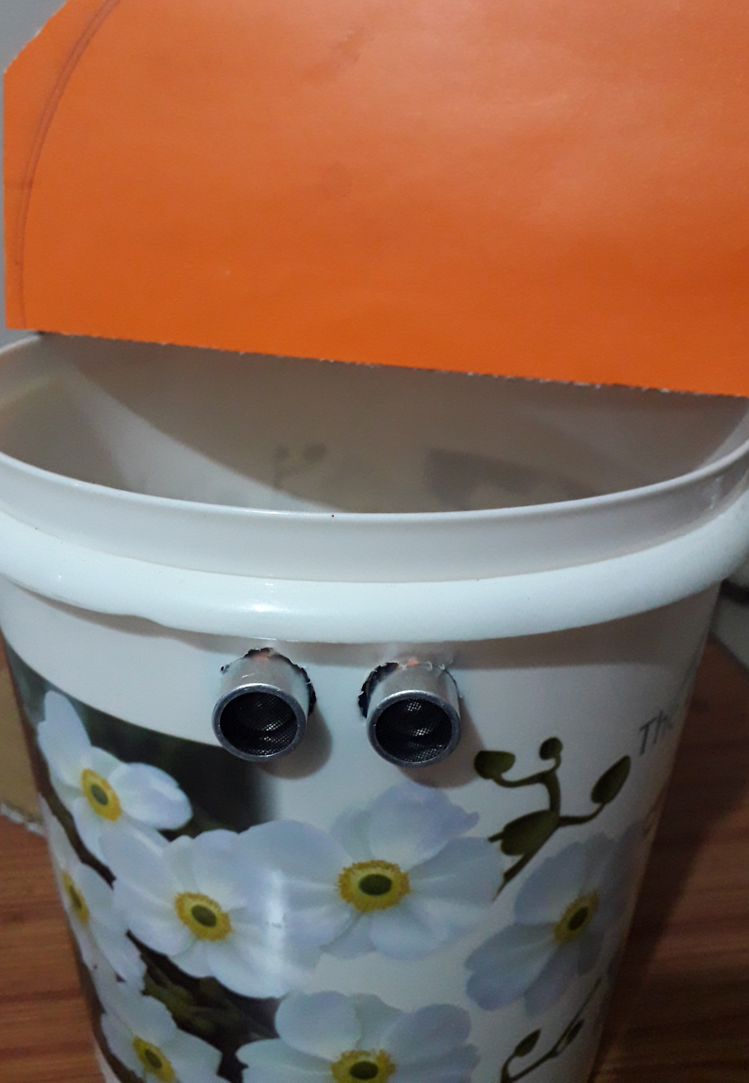

Program code.

